TOWN OF NEW DURHAM
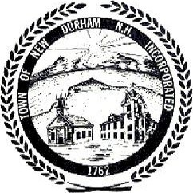
PLANNING BOARD
& Board of Selectmen
NOTICE of MEETING

New Durham Transportation Forum
Presented by the New Durham Planning Board

June 22, 2016
7:00 pm

Community Room (behind Fire Station)
New Durham, NH

